**1. SDLC: ( Software Development Life Cycle)**

It is a structured way to make sure the software is developed correctly, meets the needs of the stakeholders, adheres to quality standards and doesn’t have too many bugs.  
  
**2. Why is SDLC required?**  
SDLC offers a well defined sequence of steps i.e. planning, design, development, deploy.  
It allows better planning, estimation, easy identification of potential risks, ensures better quality, increases efficiency, easier for maintenance.  
  
**3. What are the stages of SDLC?**

**1. Requirement Gathering & Analysis**

* Understand what the client/user needs.
* Define system requirements.
* Involves stakeholders and business analysts.

**2. Planning**

* Define scope, resources, cost, and schedule.
* Create a project plan and risk assessment.

**3. Design**

* Create architecture and system design.
* Includes UI/UX design, database design, and technical specs.

**4. Development (Implementation)**

* Actual coding happens.
* Developers build the system according to design documents.

**5. Testing**

* Verify the software works as expected.
* Types: Unit Testing, Integration Testing, System Testing, etc.

**6. Deployment**

* Release the software to users.
* Can be done in phases (pilot, beta, full release).

**7. Maintenance**

* Fix bugs, update features, and ensure smooth operation.
* Ongoing process after deployment.

**4. What are the different models of SDLC??**

**1. Waterfall Model**

This is a linear approach where each phase must finish before the next starts.

It follows a strict sequence: requirements, design, implementation, testing, and maintenance.

Good for well-defined projects with clear, unchanging requirements.

Changes are hard to accommodate once the process moves forward.

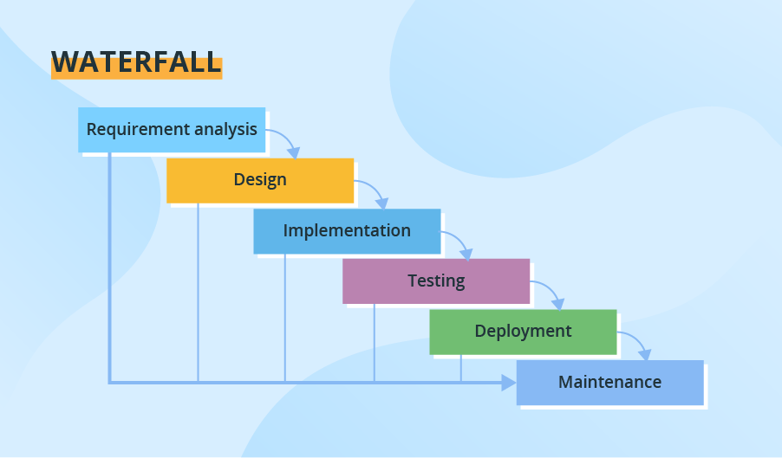

**2. V-Shaped Model**

An extension of Waterfall where testing steps are planned in parallel with development.

Every development stage has a corresponding test stage.

It ensures early detection of defects through continuous validation.

Best suited for small to medium projects with clear requirements.

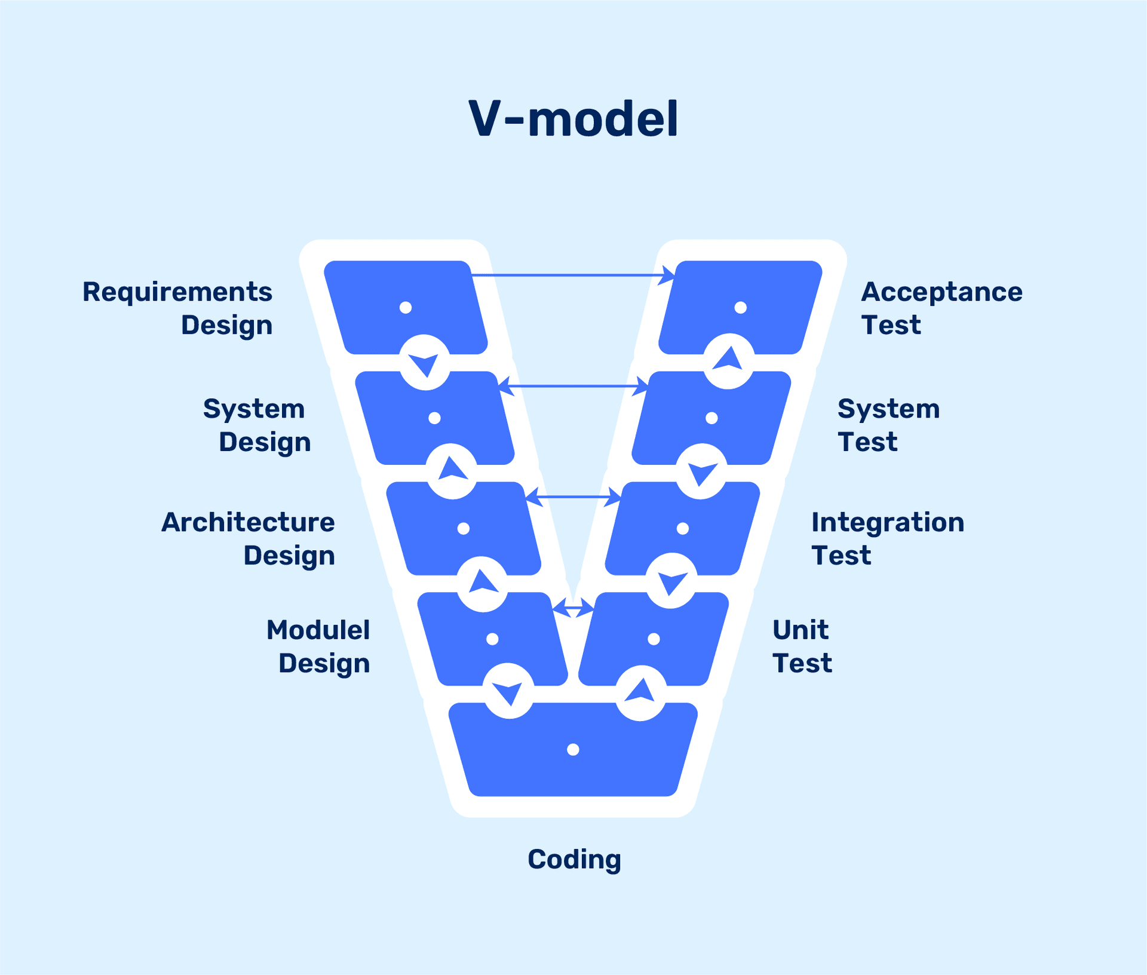

**3. Incremental Model**

The system is developed in small, functional parts called increments.

Each increment adds more features until the final system is complete.

It allows partial implementation and faster delivery of working software.

Changes and enhancements can be made after each iteration.

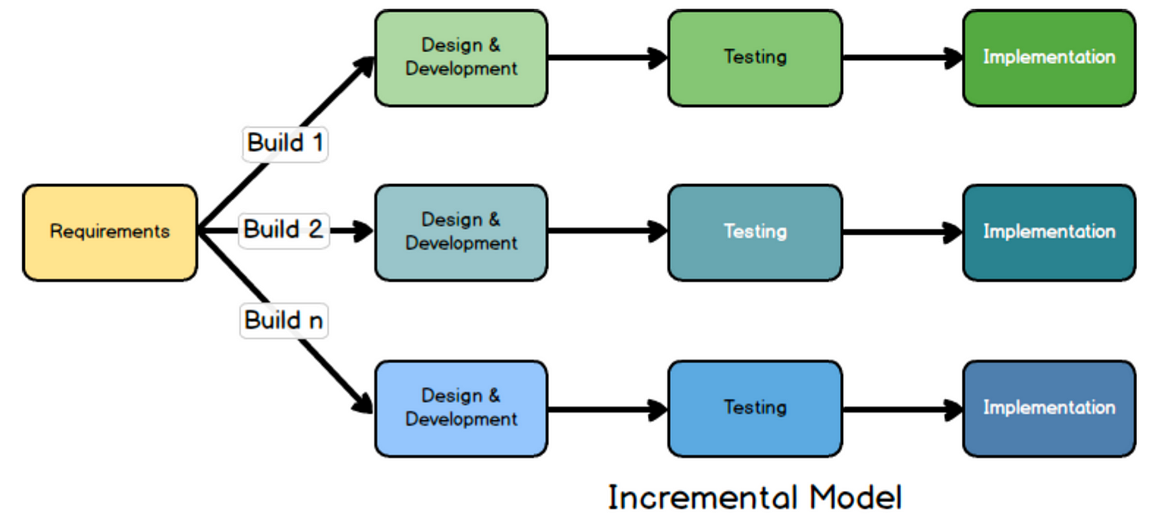

**4. Iterative Model**

Software is built and improved through repeated cycles.

Initial versions are refined based on feedback from earlier iterations.

Ideal for projects where requirements evolve over time.

Reduces risk by focusing on learning and adaptation.

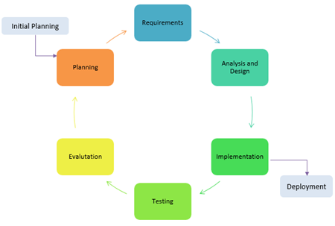

**5. Spiral Model**

Combines elements of both design and prototyping in stages.

Emphasizes risk assessment and handling throughout development.

Each loop of the spiral includes planning, risk analysis, engineering, and evaluation.

Best for large, complex, and high-risk projects.

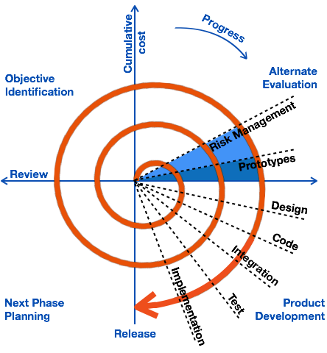

**6. Agile Model**

Focuses on flexibility, collaboration, and rapid delivery.

Work is divided into small units called sprints, often lasting 1-4 weeks.

Customer feedback is constantly integrated to adapt to changes.

Highly effective for dynamic projects needing quick turnaround.

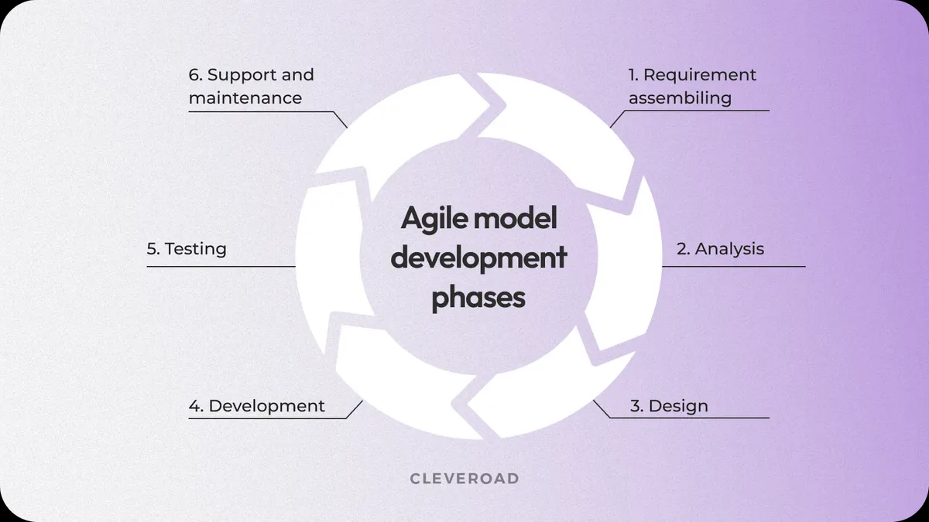

**7. RAD Model**

**RAD Model** stands for rapid application development model.   
The methodology of RAD model is similar to that of incremental or waterfall model. It is used for small projects.

The main objective of RAD model is to reuse code, components, tools, processes in project development.  
 If the project is large then it is divided into many small projects and these small projects are planned one by one and completed. In this way, by completing small projects, the large project gets ready quickly.

In RAD model, the project is completed within the given time and all the requirements are collected before starting the project. It is very fast and there are very less errors in it.  
  
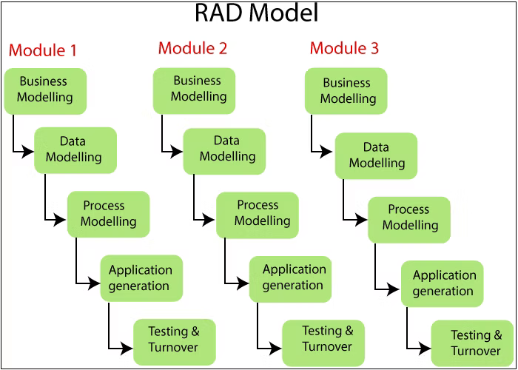  
  
**8. Prototype model**

**Prototype Model** is an activity in which prototypes of software applications are created.

First a prototype is created and then the final product is manufactured based on that prototype.

One problem in this model is that if the end users are not satisfied with the prototype model, then a new prototype model is created again, due to which this model consumes a lot of money and time.

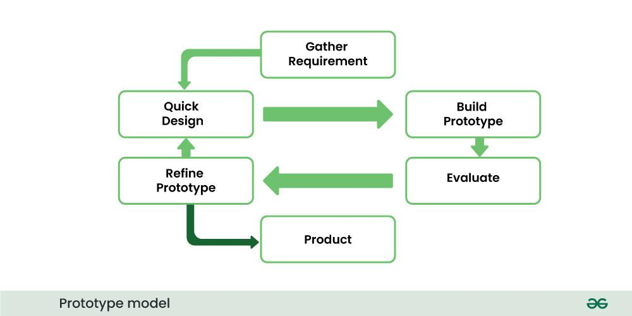

**TASK: 5**  
  
What are the different Network types?

1. **Personal Area Network (PAN):**

* This is the smallest type of network, typically covering a range of a few meters.
* It connects devices used by a single person.
* Examples include a Bluetooth connection between a smartphone and headphones, a wireless mouse and keyboard connected to a computer, or a connection between a laptop and a printer.
* PANs can be wired (like USB or FireWire) or wireless (like Bluetooth, Wi-Fi, or infrared).

1. **Local Area Network (LAN):**

* A LAN connects devices within a limited geographical area, such as a home, office, school, or a single building.
* LANs typically use technologies like Ethernet or Wi-Fi to connect computers, printers, servers, and other devices.
* They are usually owned and managed by a single organization.
* LANs allow users to share resources like files, printers, and internet access.

1. **Wireless Local Area Network (WLAN):**

* A type of LAN that uses wireless technologies like Wi-Fi (IEEE 802.11 standards) to connect devices.
* WLANs offer flexibility and mobility as devices can connect to the network without physical cables.
* They are commonly found in homes, offices, and public hotspots.

**4. Metropolitan Area Network (MAN):**

* A MAN covers a larger geographical area than a LAN, typically spanning a city or a metropolitan region.
* MANs can connect multiple LANs together.
* They are often owned and operated by a consortium of users or a network provider.
* Examples include the network used by a cable TV company to provide internet access across a city or a network connecting various government offices within a metropolis.

**5. Wide Area Network (WAN):**

* A WAN covers a broad geographical area, potentially spanning across states, countries, or even the entire world.
* The internet is the largest example of a WAN.
* WANs connect multiple LANs and MANs.
* They often utilize various communication technologies like leased lines, fiber optic cables, satellite links, and cellular networks.
* WANs are essential for businesses and organizations with operations in different locations.

**6. Campus Area Network (CAN):**

* A CAN connects multiple LANs located within a specific, limited geographical area, such as a university campus, a large corporate campus, or a military base.
* It is larger than a LAN but smaller than a MAN.
* The networking infrastructure is usually owned and managed by the organization that owns the campus.

**Task: 6**  
What is TCP and UDP? What is the difference?  
  
**TCP (Transmission Control Protocol):**

* Connection-oriented: Establishes a dedicated connection between sender and receiver before data transfer, like making a phone call.
* Reliable: Ensures that data is delivered completely, in the correct order, and without errors through acknowledgements and retransmissions.
* Slower: The overhead of setting up and maintaining the connection, along with error checking, makes it slower.
* Common Uses: Web browsing (HTTP/HTTPS), email (SMTP, POP, IMAP), file transfer (FTP, SFTP), secure shell (SSH).

**UDP (User Datagram Protocol):**

* Connectionless: Sends data packets without establishing a connection beforehand, similar to sending a postcard.
* Unreliable: Does not guarantee delivery, order, or error-free transmission; packets can be lost or arrive out of sequence.
* Faster: Lower overhead because it skips the connection establishment and reliability mechanisms.
* Common Uses: Online gaming, live streaming, Voice over IP (VoIP), DNS lookups, video conferencing.

**Difference:**  
TCP prioritizes accuracy, while UDP prioritizes speed

TCP: Reliable, connection-oriented (like a phone call), slower, guarantees delivery and order. Used for web browsing, email, file transfer.

UDP: Unreliable, connectionless (like a postcard), faster, doesn't guarantee delivery or order. Used for streaming, gaming, VoIP, DNS.

**Task 9:**

What do you know about mac address ? What is the difference between Mac address and IP address.  
  
**MAC:** The MAC (Media Access Control) address is a unique 48-bit (6-byte) hexadecimal identifier assigned to a network interface controller (NIC) by the manufacturer. It's often referred to as the physical address or hardware address of a device.  
  
  
**Difference**:  
The **MAC address** is the fixed, hardware-based identifier of a network interface, used for device-to-device communication within the same local network. Think of it as a device's permanent physical address.

The **IP address**, on the other hand, is a logical, software-assigned address that identifies a device on a network (local or the internet) for routing data between different networks. It's like a device's temporary mailing address that can change.

**Task : 10  
What is OSI Model?**

The OSI (Open Systems Interconnection) model is a conceptual framework that standardizes the functions of a telecommunication or computing system in terms of abstraction layers.

OSI is like a set of rules or a blueprint for how network communication should happen. Instead of having one big, complicated process, the OSI model breaks down network communication into seven distinct layers, each with a specific job:

1. **Physical Layer:** Deals with the physical transmission of data (bits) over a communication medium (like cables or radio waves).
2. **Data Link Layer:** Handles error-free data transfer between two directly connected nodes, organizing data into frames and managing MAC addresses.
3. **Network Layer:** Responsible for routing data packets across different networks, using IP addresses to determine the best path.
4. **Transport Layer:** Provides reliable or unreliable end-to-end data delivery between applications, managing segmentation and reassembly of data (TCP and UDP operate here).
5. **Session Layer:** Manages and controls the connections (sessions) between applications.
6. **Presentation Layer:** Handles data formatting, encryption, and compression to ensure data is understandable by the application layer.
7. **Application Layer:** Provides network services directly to end-user applications (like web browsers, email clients).

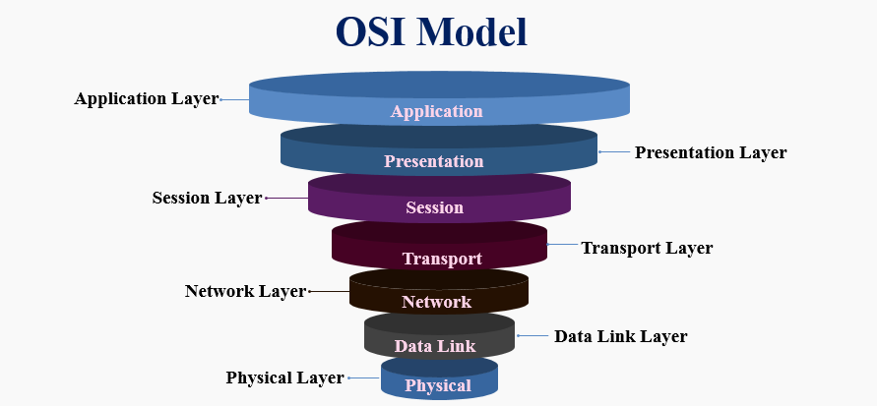

**Task 11:**

What is an IPv4 address? What are the different classes of IPv4?

An **IPv4 address** is a unique number assigned to every device that connects to the internet or a computer network. It’s like a home address for your computer, smartphone, or any other device, allowing it to communicate with other devices.

IPv4 addresses are typically written in **dotted decimal notation**, consisting of four 8-bit numbers (octets) separated by periods (e.g., 192.168.1.1). Each octet can range from 0 to 255.

**Classes of IP Addressing**

The 32-bit IP address is divided into five sub-classes. These are given below:

**Class A:**

* Range: 1.0.0.0 - 126.255.255.255
* First Octet: 0 (first bit is 0)
* Default Subnet Mask: 255.0.0.0 (/8)
* Intended for: Very large networks with a small number of networks and a large number of hosts per network.

**Class B:**

* Range: 128.0.0.0 - 191.255.255.255
* First Octet: 10 (first two bits are 10)
* Default Subnet Mask: 255.255.0.0 (/16)
* Intended for: Medium-sized networks with a moderate number of networks and a moderate number of hosts per network.

**Class C:**

* Range: 192.0.0.0 - 223.255.255.255
* First Octet: 110 (first three bits are 110)
* Default Subnet Mask: 255.255.255.0 (/24)
* Intended for: Small networks with a large number of networks and a small number of hosts per network.

**Class D:**

* Range: 224.0.0.0 - 239.255.255.255
* First Octet: 1110 (first four bits are 1110)
* Used for: Multicasting, where data is sent to a group of hosts.

**Class E:**

* Range: 240.0.0.0 - 255.255.255.255
* First Octet: 1111 (first four bits are 1111)
* Reserved for: Experimental purposes and future use.

**Task 12:  
Advantages of using VPN:**

* **Enhanced Security**: VPNs encrypt your internet traffic, especially on public Wi-Fi, protecting your data from hackers and eavesdroppers.
* ***Privacy Protection***: They mask your real IP address, making it harder for websites, advertisers, and your ISP to track your online activity and location.
* ***Bypassing Restrictions***: VPNs can help you access geo-blocked content and bypass internet censorship by routing your connection through servers in different locations.
* ***Increased Anonymity***: By hiding your IP address and encrypting your data, VPNs provide a greater level of anonymity while you browse the internet.
* **Secures Public Wi-Fi:** VPNs encrypt your connection on unsecured public networks, safeguarding sensitive data from potential theft.  
    
  **Task- 13:**  
  **Types of VPN:**

* **Site-to-Site VPN**: Securely links entire networks at different locations over a public network.
* **Access VPN:** Securely connects individual remote users to a private network.
* **Intranet VPN:** Securely links different locations within the same organization's private network.
* **Extranet VPN:** Provides controlled, secure access to parts of an intranet for authorized external partners.

**Task:14  
Node and link**A **node** is any active point in a network capable of sending, receiving, or forwarding data (e.g., computers, routers).

A **link** is the communication pathway or medium connecting nodes, allowing data exchange (e.g., cables, Wi-Fi).

**Task- 15:  
What is Topology:**

Topology refers to the physical or logical arrangement of devices, nodes, and connections within a network. It defines how these components are interconnected and how data is transmitted between them.

**Task- 16:**

**What are the different types of Network Topology ?**

1. **Point to Point Topology**

Point-to-point topology is a type of topology that works on the functionality of the sender and receiver. It is the simplest communication between two nodes, in which one is the sender and the other one is the receiver. Point-to-Point provides high bandwidth.

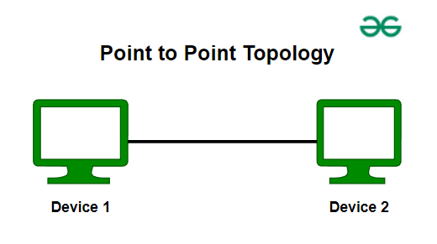

1. **Mesh Topology**

In a mesh topology, every device is connected to another device via a particular channel. Every device is connected to another via dedicated channels. These channels are known as links. In Mesh Topology, the protocols used are AHCP (Ad Hoc Configuration Protocols), [DHCP](https://www.geeksforgeeks.org/dynamic-host-configuration-protocol-dhcp/) (Dynamic Host Configuration Protocol), etc.

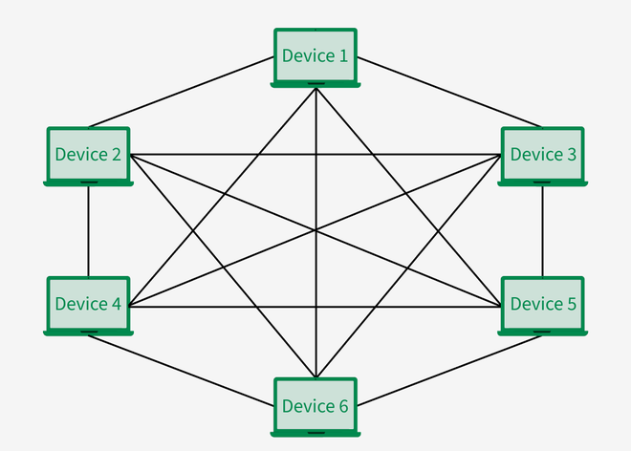

* Suppose, the N number of devices are connected with each other in a mesh topology, the total number of ports that are required by each device is N-1. In Figure , there are 6 devices connected to each other, hence the total number of ports required by each device is 5. The total number of ports required = N * (N-1).
* Suppose, N number of devices are connected with each other in a mesh topology, then the total number of dedicated links required to connect them is N C 2 i.e. N(N-1)/2. In Figure, there are 6 devices connected to each other, hence the total number of links required is 6*5/2 = 15.

**Advantages of Mesh Topology**

* Communication is very fast between the nodes.
* Mesh Topology is robust.
* The fault is diagnosed easily. Data is reliable because data is transferred among the devices through dedicated channels or links.
* Provides security and privacy.

**Disadvantages of Mesh Topology**

* Installation and configuration are difficult.
* The cost of cables is high as bulk wiring is required, hence suitable for less number of devices.
* The cost of maintenance is high.

A common example of mesh topology is the internet backbone, where various internet service providers are connected to each other via dedicated channels. This topology is also used in military communication systems and aircraft navigation systems.

1. **Star Topology**

In Star Topology, all the devices are connected to a single hub through a cable. This hub is the central node and all other nodes are connected to the central node. The hub can be passive in nature i.e., not an intelligent hub such as broadcasting devices, at the same time the hub can be intelligent known as an active hub. Active hubs have repeaters in them. Coaxial cables or RJ-45 cables are used to connect the computers. In Star Topology, many popular [Ethernet](https://www.geeksforgeeks.org/what-is-ethernet/) LAN protocols are used as CD(Collision Detection), [CSMA](https://www.geeksforgeeks.org/carrier-sense-multiple-access-csma/) (Carrier Sense Multiple Access), etc.

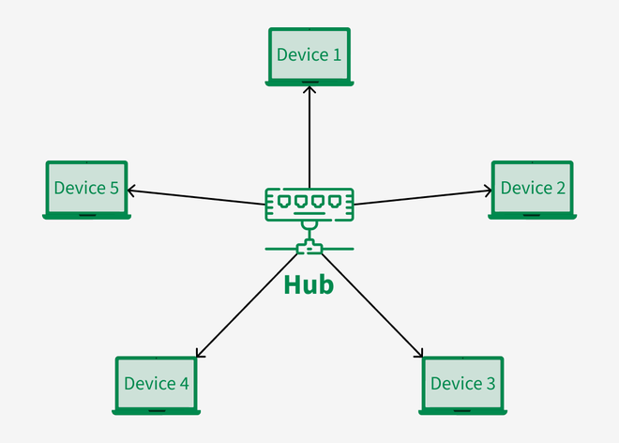

**Advantages of Star Topology**

* If N devices are connected to each other in a star topology, then the number of cables required to connect them is N. So, it is easy to set up.
* Each device requires only 1 port i.e. to connect to the hub, therefore the total number of ports required is N.
* It is Robust. If one link fails only that link will affect and not other than that.
* Easy to fault identification and fault isolation.
* Star topology is cost-effective as it uses inexpensive coaxial cable.

**Disadvantages of Star Topology**

* If the concentrator (hub) on which the whole topology relies fails, the whole system will crash down.
* The cost of installation is high.
* Performance is based on the single concentrator i.e. hub.

A common example of star topology is a **local area network (LAN)** in an office where all computers are connected to a central hub. This topology is also used in wireless networks where all devices are connected to a wireless access point.

1. **Bus Topology**

Bus Topology is a network type in which every computer and network device is connected to a single cable. It is bi-directional. It is a multi-point connection and a non-robust topology because if the backbone fails the topology crashes. In Bus Topology, various [MAC](https://www.geeksforgeeks.org/mac-address-in-computer-network/) (Media Access Control) protocols are followed by LAN ethernet connections like [TDMA](https://www.geeksforgeeks.org/difference-between-fdma-tdma-and-cdma/), [Pure Aloha](https://www.geeksforgeeks.org/what-is-pure-aloha/), CDMA, [Slotted Aloha](https://www.geeksforgeeks.org/what-is-slotted-aloha/), etc.

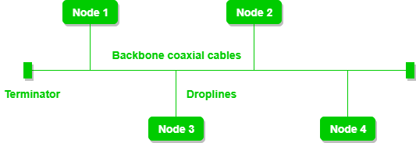

**Advantages of Bus Topology**

* If N devices are connected to each other in a bus topology, then the number of cables required to connect them is 1, known as backbone cable, and N drop lines are required.
* Coaxial or twisted pair cables are mainly used in bus-based networks that support up to 10 Mbps.
* The cost of the cable is less compared to other topologies, but it is used to build small networks.
* Bus topology is familiar technology as installation and troubleshooting techniques are well known.
* [CSMA](https://www.geeksforgeeks.org/carrier-sense-multiple-access-csma) is the most common method for this type of topology.

**Disadvantages of  Bus Topology**

* A bus topology is quite simpler, but still, it requires a lot of cabling.
* If the common cable fails, then the whole system will crash down.
* If the network traffic is heavy, it increases collisions in the network. To avoid this, various protocols are used in the MAC layer known as Pure Aloha, Slotted Aloha, CSMA/CD, etc.
* Adding new devices to the network would slow down networks.
* Security is very low.

A common example of bus topology is the Ethernet LAN, where all devices are connected to a single coaxial cable or twisted pair cable. This topology is also used in cable television networks.

1. **Ring Topology**

In a Ring Topology, it forms a ring connecting devices with exactly two neighboring devices. A number of repeaters are used for Ring topology with a large number of nodes, because if someone wants to send some data to the last node in the ring topology with 100 nodes, then the data will have to pass through 99 nodes to reach the 100th node. Hence to prevent data loss repeaters are used in the network.

The data flows in one direction, i.e. it is unidirectional, but it can be made bidirectional by having 2 connections between each Network Node, it is called Dual Ring Topology. In-Ring Topology, the Token Ring Passing protocol is used by the workstations to transmit the data.

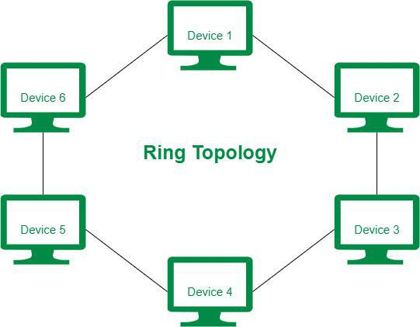

The most common access method of ring topology is token passing.

* **Token passing:** It is a network access method in which a token is passed from one node to another node.
* **Token:** It is a frame that circulates around the network.

**Operations of Ring Topology**

* One station is known as a **monitor** station which takes all the responsibility for performing the operations.
* To transmit the data, the station has to hold the token. After the transmission is done, the token is to be released for other stations to use.
* When no station is transmitting the data, then the token will circulate in the ring.
* There are two types of token release techniques: **Early token release** releases the token just after transmitting the data and **Delayed token release** releases the token after the acknowledgment is received from the receiver.

**Advantages of Ring Topology**

* The data transmission is high-speed.
* The possibility of collision is minimum in this type of topology.
* Cheap to install and expand.
* It is less costly than a star topology.

**Disadvantages of Ring Topology**

* The failure of a single node in the network can cause the entire network to fail.
* Troubleshooting is difficult in this topology.
* The addition of stations in between or the removal of stations can disturb the whole topology.
* Less secure.

1. **Tree Topology**

Tree topology is the variation of the Star topology. This topology has a hierarchical flow of data. In Tree Topology, protocols like [DHCP](https://www.geeksforgeeks.org/dynamic-host-configuration-protocol-dhcp/) and **SAC (Standard Automatic Configuration)** are used.

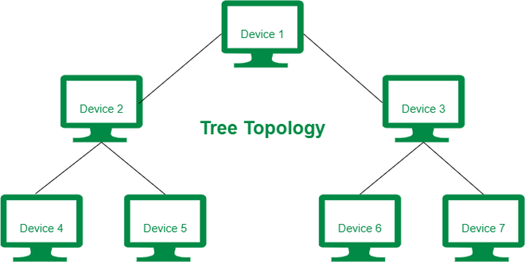

In tree topology, the various secondary hubs are connected to the central hub which contains the repeater. This data flow from top to bottom i.e. from the central hub to the secondary and then to the devices or from bottom to top i.e. devices to the secondary hub and then to the central hub. It is a [multi-point connection](https://www.geeksforgeeks.org/differences-between-point-to-point-and-multi-point-communication/) and a non-robust topology because if the backbone fails the topology crashes.

**Advantages of Tree Topology**

* It allows more devices to be attached to a single central hub thus it decreases the distance that is traveled by the signal to come to the devices.
* It allows the network to get isolated and also prioritize from different computers.
* We can add **new devices to the existing network.**
* **Error detection** and **error correction** are very easy in a tree topology.

**Disadvantages of Tree Topology**

* If the central hub gets fails the entire system fails.
* The cost is high because of the cabling.
* If new devices are added, it becomes difficult to reconfigure.

A common example of a tree topology is the hierarchy in a large organization. At the top of the tree is the CEO, who is connected to the different departments or divisions (child nodes) of the company. Each department has its own hierarchy, with managers overseeing different teams (grandchild nodes). The team members (leaf nodes) are at the bottom of the hierarchy, connected to their respective managers and departments.

1. **Hybrid Topology**

Hybrid Topology is the combination of all the various types of topologies we have studied above. Hybrid Topology is used when the nodes are free to take any form. It means these can be individuals such as Ring or Star topology or can be a combination of various types of topologies seen above. Each individual topology uses the protocol that has been discussed earlier.

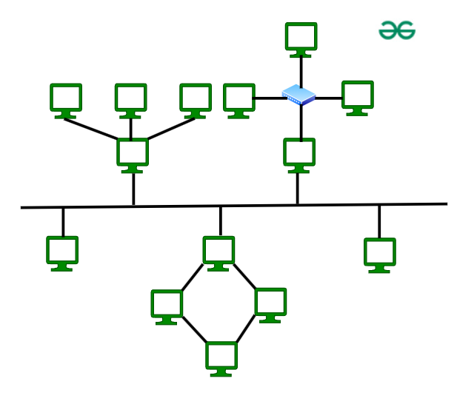

The above figure shows the structure of the Hybrid topology. As seen it contains a combination of all different types of networks.

**Advantages of Hybrid Topology**

* This topology is **very flexible** .
* The size of the network can be easily expanded by **adding new devices.**

**Disadvantages of Hybrid Topology**

* It is challenging **to design the architecture** of the Hybrid Network.
* **Hubs** used in this topology are **very expensive.**
* The infrastructure cost is very high as a hybrid network **requires a lot of cabling and network devices** .

**Task 17:**

**What is extended bus topology ?**

**Task:18:**

**Difference between router and gateway :**

* **Router:** Forwards data between networks using the same protocols.
* **Gateway:** Connects networks using different protocols by translating data.

**Task 19:**

**Explain SMTP Protocol with diagram.**

Simple Mail Transfer Protocol (SMTP) is an application layer protocol used for exchanging email messages between servers. It is essential in the email communication process and operates at the application layer of the TCP/IP stack.

To send an email, the client opens a TCP connection to the SMTP server. The server, which is always listening on port 25, initiates the connection as soon as it detects a client. Once the TCP connection is established, the client sends the email across the connection.

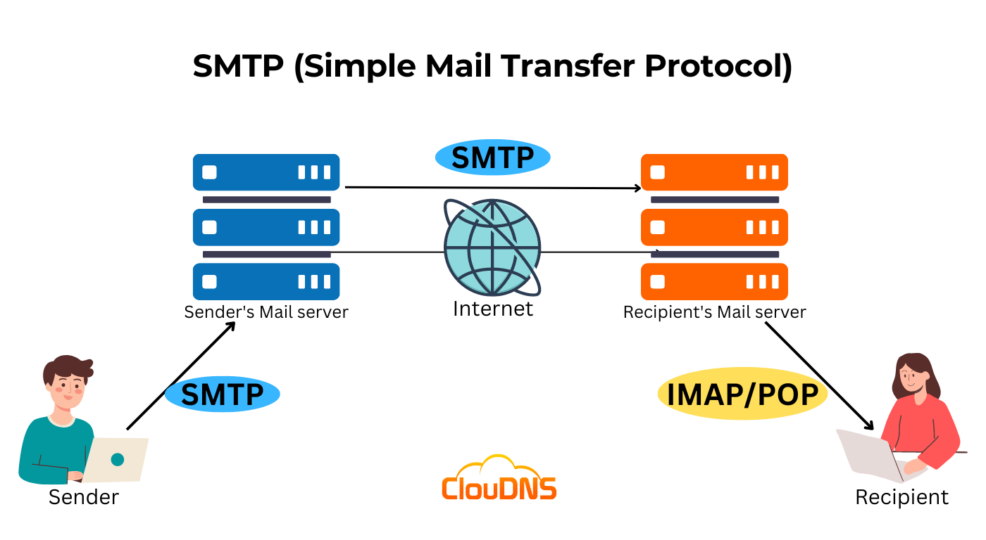

**Task- 20:  
Differentiate between OSI and TCP/IP**

* OSI is the detailed blueprint for how a perfect communication system should be built, with all the ideal stages and departments. It's like the theoretical design of a super-efficient postal service with very specific roles for everyone.
* TCP/IP is the actual, working model of the internet's communication system. It's more practical and combines some of those ideal stages into fewer, more flexible departments that get the job done. It's like the real-world postal service that might have people wearing multiple hats to deliver your mail.

**Task- 22:**

**What is Low Level Design and  High level Design. Explain**

* **High-Level Design (HLD):** A broad blueprint outlining the system's major components, their interactions, and overall architecture.
* **Low-Level Design (LLD):** A detailed specification describing the internal structure and implementation details of individual components defined in the HLD.

**Task:23:**

**What is SRS? With Diagram**

SRS stands for (Software Requirements Specification).

It's a document that describes the requirements for a software system, outlining what it should do, how it should perform, and under what conditions.

Essentially, it's a blueprint for the software, helping stakeholders understand the project and guiding the development team.

The SRS is a key input to other development documents, such as the system design document and the test plan.

An SRS typically includes sections on the software's intended purpose, functional and non-functional requirements, use cases, interface specifications, and constraints.

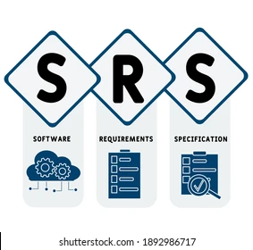

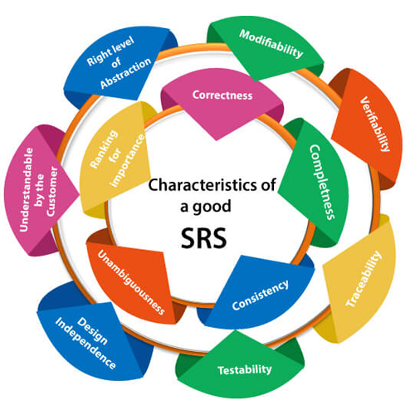

**SDLC MCQ**

1.

A feasibility study using the SDLC model is conducted to

determine whether or not the project is technically possible

determine whether the proposal is financially viable

Both a and b

None of the above

2.

A well-documented life cycle model aids in the detection of what during the development phase?

Inconsistencies

Redundancies

Omission

All of the above

3.

How many lines of code does the Build & Fix Model suit for programming exercises?

100-200

300-400

600-700

Above 800+

4.

In which life cycle does regression testing play a significant role?

Waterfall model

V model

Iterative model

All of the above

5.

What determines if the project should go forward?

feasibility assessment

opportunity identification

system evaluation

program specification

6.

What is the most significant disadvantage of employing the RAD Model?

Developers/designers that are highly specialized and skilled are required.

Component reusability is improved.

Encourages client/customer input.

Increases component reusability.

7.

Which of the following developmental models is incremental?

Prototyping, V model, Agile

Prototyping, RAD, Agile, RUP

Prototyping, V model, RAD, Agile, RUP

All of the above

8.

Which of the following is an Agile development characteristic?

Shared code ownership

Test-Driven Development

Implement the simplest solution to meet today's problem

Continual feedback from customer

All of the above

9.

Which of the following steps in the SDLC framework are valid?

Requirement Gathering

Software Design

System Analysis

All of the above

10.

Who is in charge of system development, staffing, budgeting, and reporting, as well as ensuring that deadlines are met?

Project managers

Network engineers

Graphic designers

Systems analysts